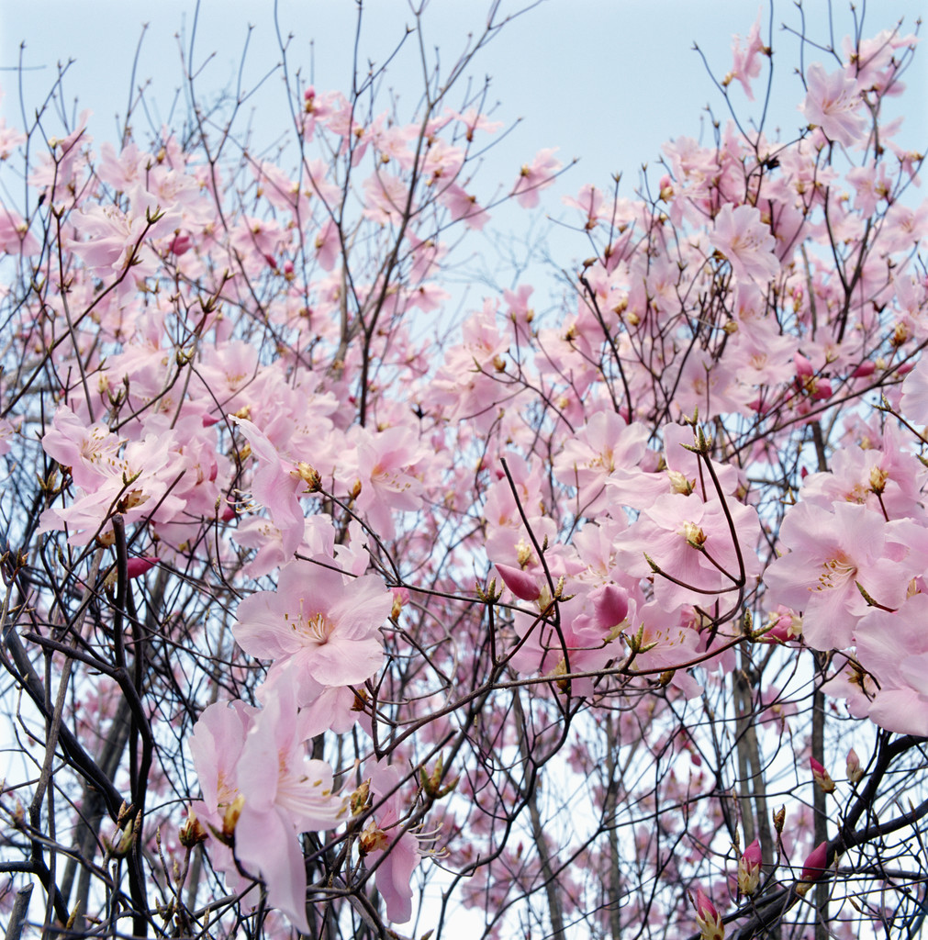 | Your Information  Relations Information
  Your Name:
  Your Spouse’s Name:
  Your children are:
  Your Address:
  Your Home/Cell:
  Your email:
  Your Birthday/Anniversary:
  Your Parents are:
  Which Ortega member do you represent? | Rudy Ortega Gloria Rios  Francisca Solis  Stella O. Diaz Rebecca Velasquez
  Social Information
  List hobbies, interests, talents and memberships:
  What do you want others to know about you?
  What is your greatest accomplishment?
  What is your next goal?
  Where was your last vacation?
  Do you have a special “Ortega” memory you would like to share with the whole family?
  Would you like to participate in a family reunion committee by representing your clan?
  Do you have an Ortega family history question to ask Tio Rudy?

